CYB 310 Module Four Lab Worksheet

Andree Salvo
Southern New Hampshire University
CYB 410 - 4-2 Lab Worksheet
Instructor: Raschid Muller
9/1/2025
Lab: Identifying & Analyzing Network Host Intrusion Detection System Alerts

Prompt | Response
In the lab, “Analyzing Network Events Using Snorby,” Step 18, take a screenshot of the alert window showing signature information and TCP header information. | 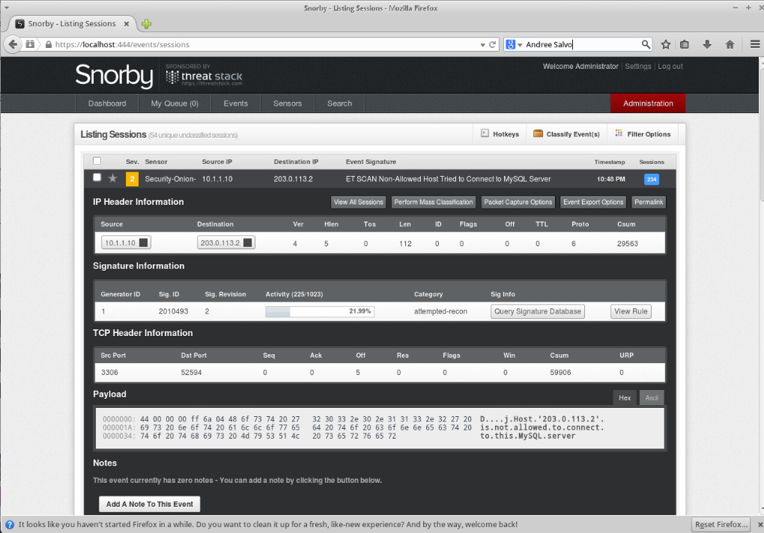
In the lab section, “Network Security Monitoring with Squert,” in the lab, “Analyzing Network Events Using Squert,” Step 11, take a screenshot of the Squert window displaying filtered scans for ip 203.0.113.2. | 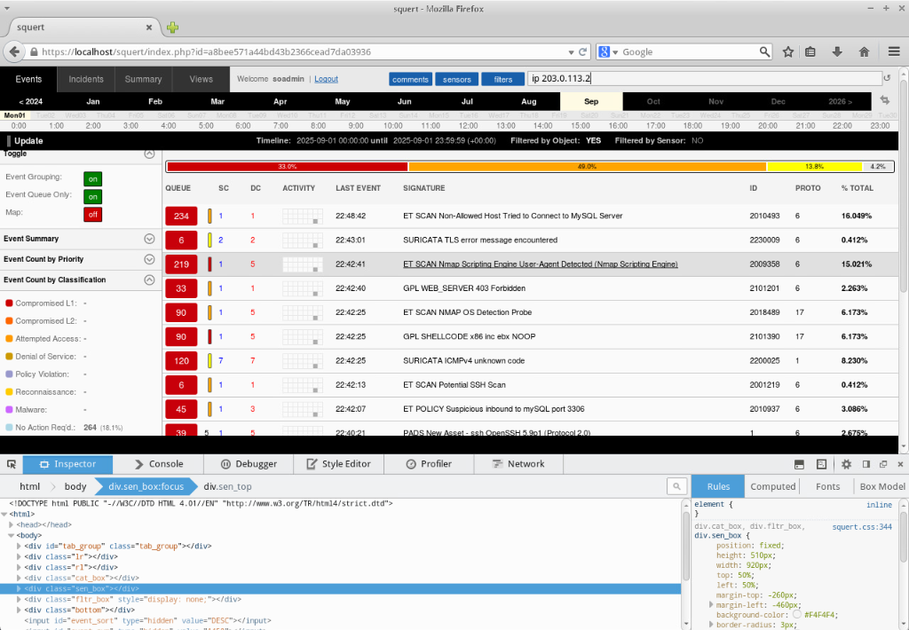
In the lab section, “Network Security Monitoring with Squert,” in the lab, “Analyzing Network Events Using Squert,” Step 17, take a screenshot of the Squert window displaying no results when filtering events for ip 10.1.1.10. | 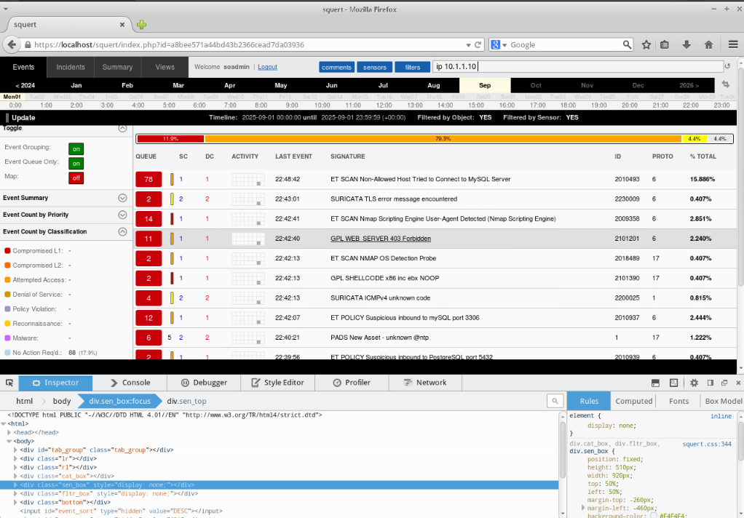
There are a variety of network analyzers. Which tool did you feel was the most powerful and easiest to use? | I would have to say Squert because it was super easy to use, provided numerous options, and everything was color-coded.
Why is it important to add network analyzer tools to your cybersecurity analyst skill set? | It’s important to add a network analyzer tool to your skill set because they let you inspect traffic, detect anomalies, and quickly respond to security threats.
How will you use network analyzer tools in a professional manner? | I’ll utilize network analyzer tools professionally by focusing on monitoring traffic, identifying issues, and enhancing security without compromising user privacy.

Lab: Intrusion Detection Using Snort
Prompt | Response
In the lab section, “Setting up the Sniffer,” Step 19, type your name after the command prompt and take a screenshot of the output after running the tcpdump -i eth1 command. | 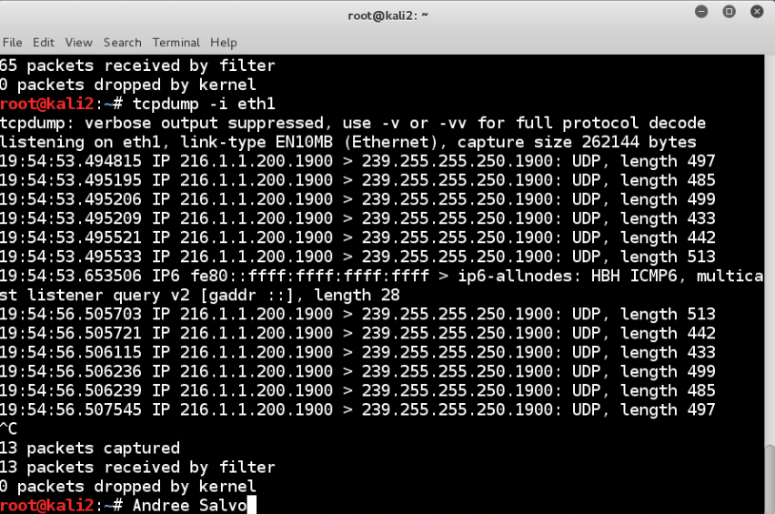
In the lab section, “Detecting Unwanted Incoming Attacks,” Step 9, take a screenshot of the results in the Bruter window after it has cycled through the dictionary words. | 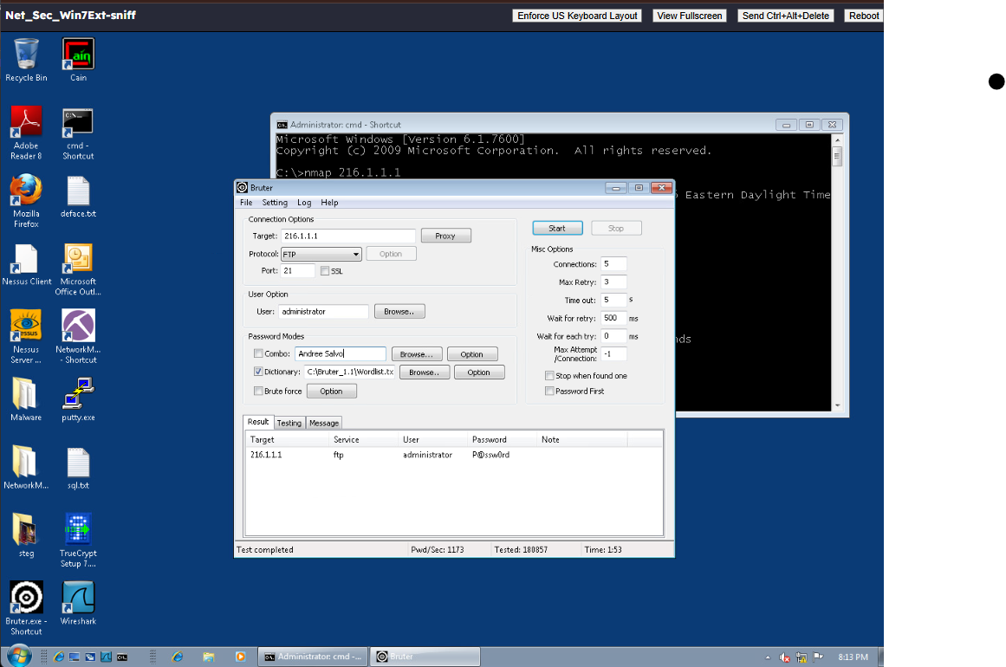
In the lab, “Detecting Unwanted Outgoing Traffic,” Step 6, type your name at the command prompt and take a screenshot of the output of the payload generated. | 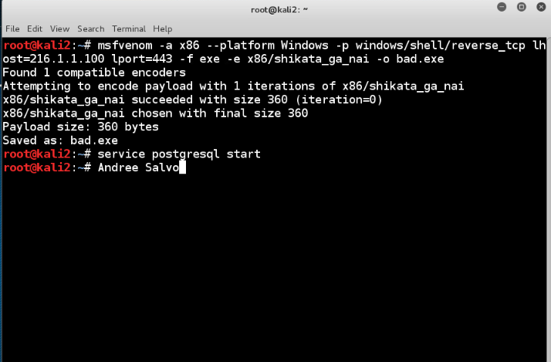
How can you see what options are available for the tcpdump command? How can this tool be used by a security analyst? | You can view the tcpdump option by typing tcpdump –help. This tool assists security analysts by capturing and analyzing network traffic to detect threats, investigate incidents, or troubleshoot issues.
What command will display all of the Ethernet interfaces within Linux? How can this be valuable to a security analyst? | The Ifconfig command will show all the interfaces on a system. This coimmand can let security analyst configure interfaces.

Detecting Malware and Unauthorized Devices

Prompt | Response
In the lab, “Keyloggers,” Step 6, scroll up to the prompt where you typed the nmap command and take a screenshot of the output from the scan. Be sure to include the timestamp at the top (date and time). | 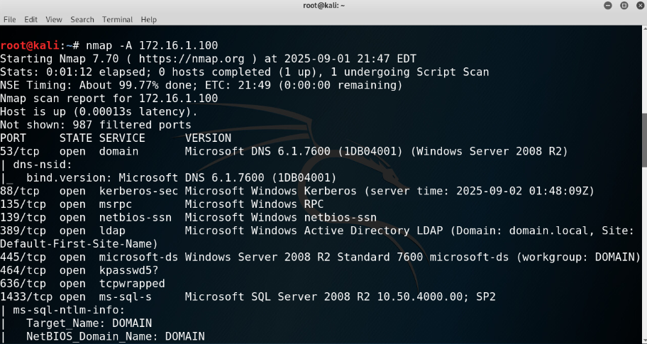
In the lab, “Keyloggers,” Step 21, take a screenshot of the successful migration after running the migrate command. Note: The number you use will be different from the one in the example. | 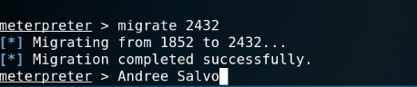
In the lab, “Keyloggers,” Step 30, take a screenshot of the output after running the kerberos command. Scroll up to the prompt where you typed the command and include the administrator password in your screenshot to show the success of the keylogger dump. | 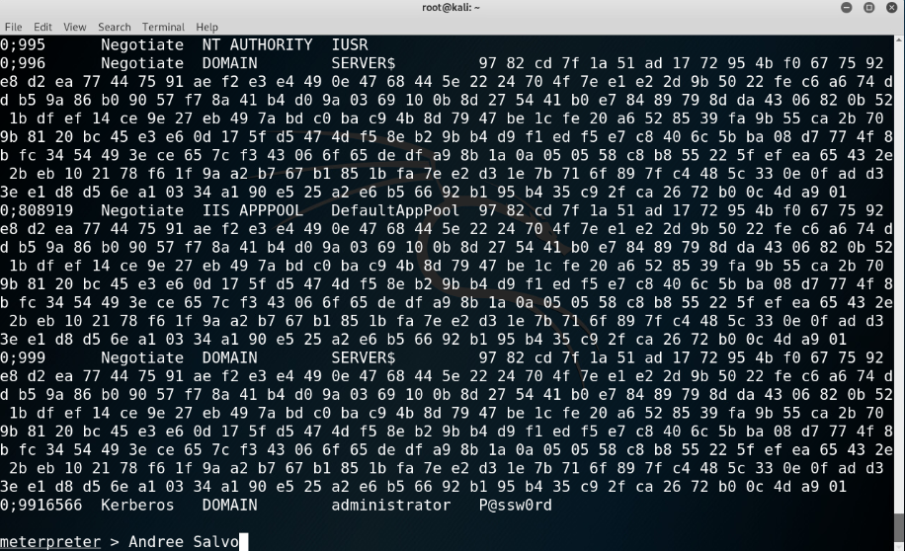
In the lab, “Examining Malware,” Step 32, take a screenshot of the History tab in Windows Defender showing the quarantined file that was detected. | 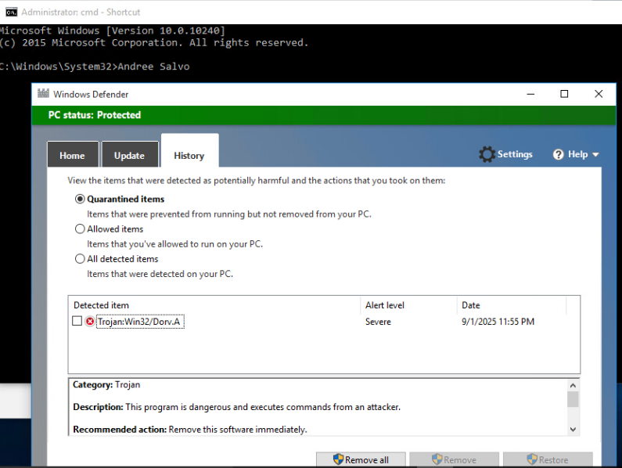
Explain the difference between active and passive scanning tools and techniques. | Active scanning tools directly interact with systems to find vulnerabilities, while passive scanning tools quietly observe network traffic without sending probes.
Explain the significance of the kerberos output. | The Kerberos output matters because it shows the authentication process and ticket activity, which helps confirm secure logins and spot any suspicious or unauthorized access.

